**Cyber Security - Assignment 01**

**Code:**

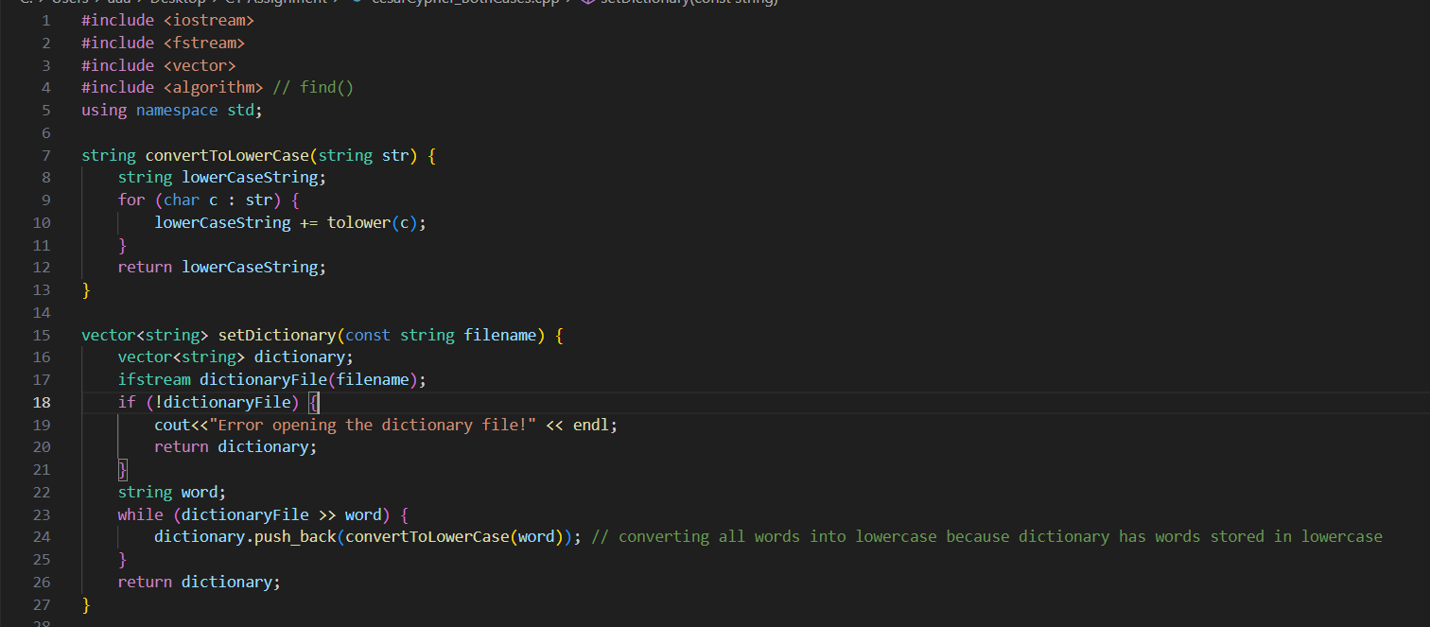

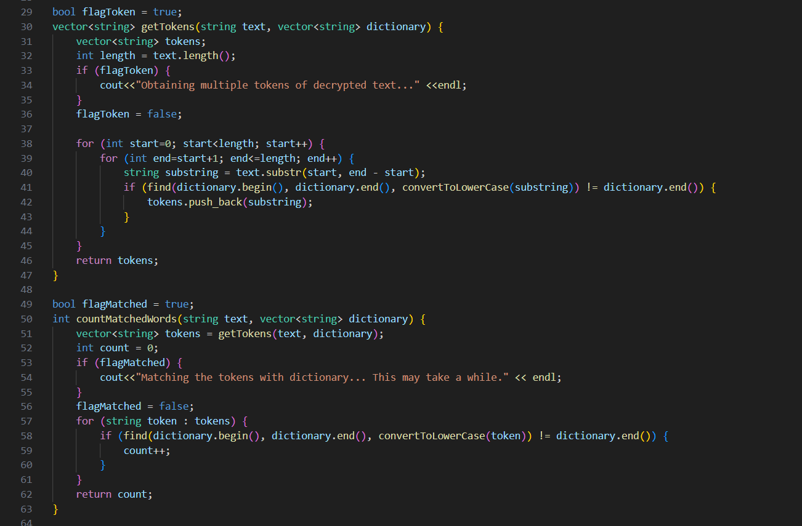

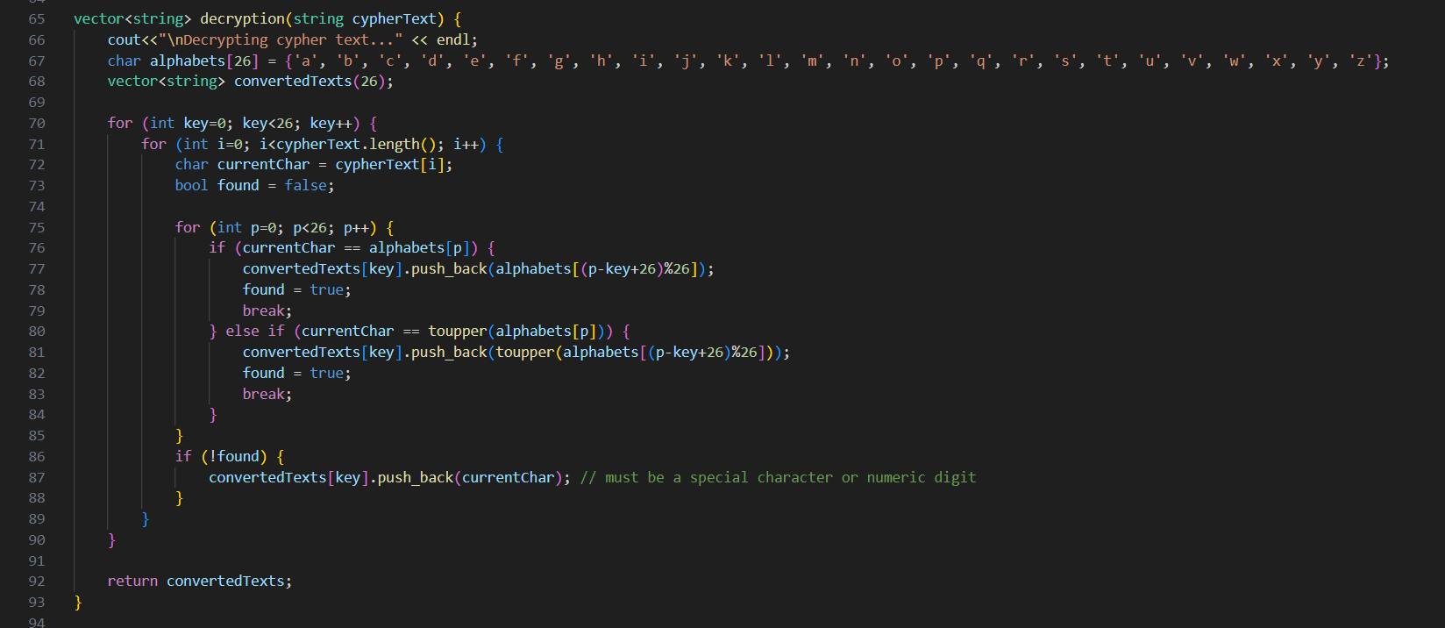

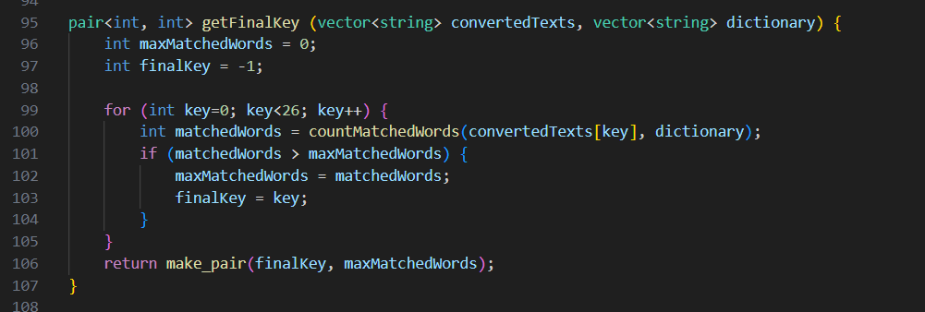

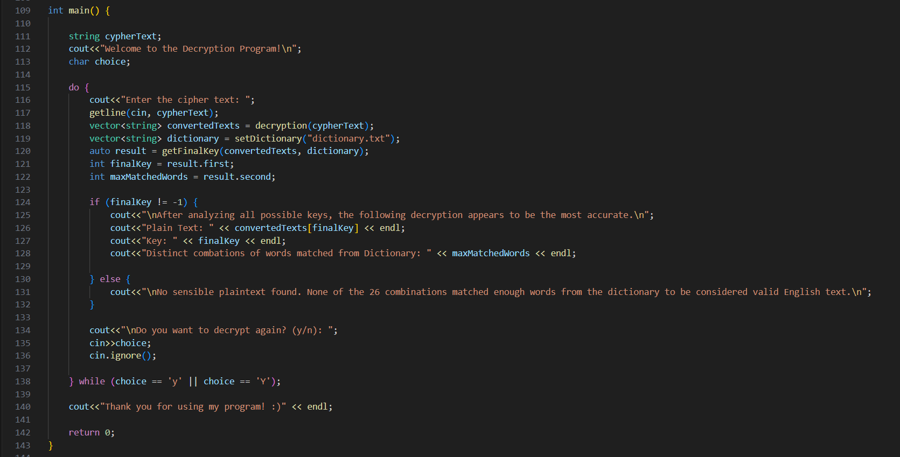

**Output:**

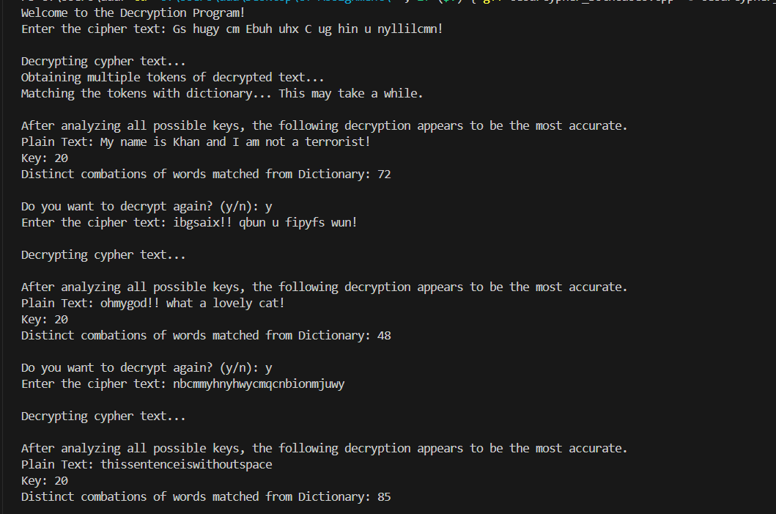

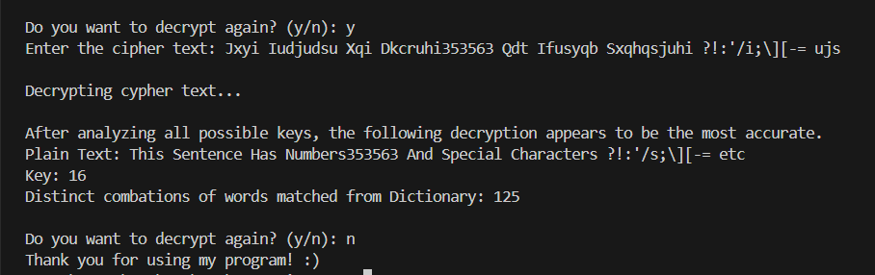

**Conclusion:**

As evident in the output snapshots, the program was tested on different cypher text inputs and for each of them, it yielded the correct plain text along with the key.